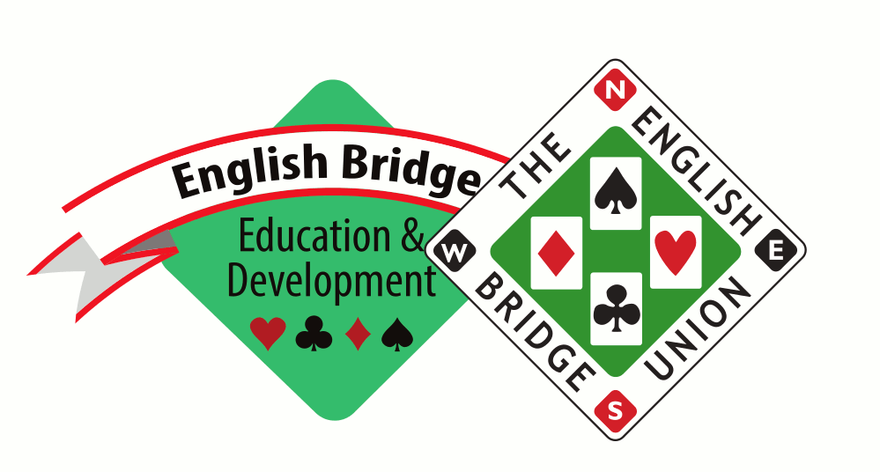

NOMINATION FORM FOR TOM BRADLEY AWARD

The Tom Bradley Award is given in recognition of a Services to Education for significant contribution to Youth Bridge to a (non school) teacher.

Typical achievements might include: major contribution to Junior Bridge Development; creating a sustained interest in bridge ; interaction with the adult bridge community; support for Junior Award Scheme; promotion of academic and non- academic benefits of bridge within the community.

Please provide name and details of nominee achievements using some or all of the criteria above.

Full Name:

Declaration

I confirm to the best of my knowledge that the information that I have provided in this nomination form is accurate and true.

Nominated by:

Signature:

Date:

Your nomination will be reviewed by the EBU Awards Sub Committee, who will be in contact in due course with in the parameters of the nomination process.

CLOSING DATE FOR NOMINATIONS IS 31st July

Please send completed forms to EBED. Email: youth@ebedcio.org.uk

