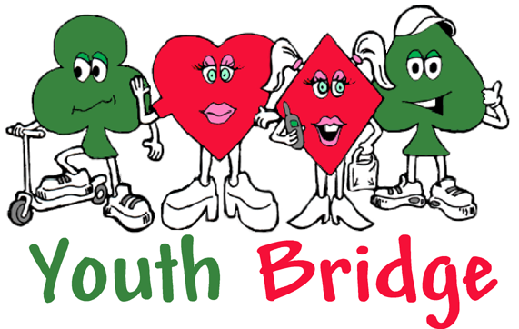
JUNIOR ‘TEACH-IN’
1st to 3rd September 2017

Loughborough University
All levels catered for – absolute beginners to junior experts. Come and enjoy a packed weekend of bridge entertainment, tuition, coaching and play for all young people under the age of 21. With plenty of fun and social activities included.

Only £160* per student inclusive of all meals, two nights’ en-suite accommodation and all the bridge fun.

* An early Bird discount of £20 will be applied for each delegate booked and paid for by 9th June 2017.

Your non-bridge playing friends and relatives may like to try out the game.

Why not bring them along?

Accompanying adults welcome, at £175* each
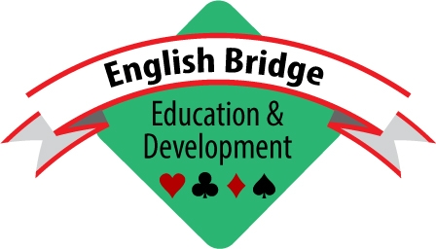

The programme in outline:
JUNIOR ‘TEACH-IN’ WEEKEND
held at Loughborough University

- Arrive Friday late afternoon to meet before dinner at 6pm.
- Bridge starts Friday evening, and continues, with a few breaks to catch your breath, until Sunday afternoon (but there’s time on Saturday afternoon for sporting and recreational activity, including tennis, swimming and rounders).
- Lots of tuition and Saturday evening tournament for all − with prizes!
- Saturday Midnight ‘Speedball’ event for the extra keen.
- Opportunities for everyone to join in with quizzes and leisure activities.
- Finish in good time to get home early on Sunday evening.

Venue: | Accommodation : single study bedrooms at Loughborough University
Date: | 1st to 3rd September 2017
Start: | Friday 3-5pm (registration) | Finish: | Sunday 3-3:30pm
Accelerated course for older teenagers – novice to player in a weekend.
Introduction of Junior Awards Scheme with Certificates of Achievement.
Playing Programme for accompanying adults.
Meet the Experts.
The main event will be for the GW Arnott-Davidson Trophy.
Bidding Challenge.

Please return completed form and payment to:
Lisa Miller, English Bridge Education & Development
Broadfields, Bicester Road, Aylesbury HP19 8AZ lisa@ebu.co.uk  01296 317217

Registered Charity No: 1153543

Junior Teach-In Application Form
(PLEASE COMPLETE IN CAPITALS)
1.  Name  Address |  | ……………………………………………………….……………  ……………………………………………….……………………  ……………….…………………………………………………… |  |  |  |  |  |  |  |  |  |  |  | DOB  EBU No: | ......../……../20……  ……………………... | Gender  M/F
  Students email address: …………………………………………………………..… Non-resident
2.  Name  Address |  | ………………………………………………….…………………  …………………………………………………….………………  ………………...………………………………………………….. |  |  |  |  |  |  |  |  |  |  |  | DOB  EBU No: | ……../……../20……  ……………………... | Gender  M/F
  Students email address: …………………………………………………………...… Non-resident
3.  Name  Address |  | ……………………………………….……………………………  …………………………………………………………….………  …………………………………………………………………….. |  |  |  |  |  |  |  |  |  |  |  | DOB  EBU No: | ……../……../20……  ……………………... | Gender  M/F
  Students email address: …………………………………………………………...… Non-resident
4.  Name  Address |  | ……………………………………………………………….……  …………………………………………………………………….  …………………………………………………………………….. |  |  |  |  |  |  |  |  |  |  |  | DOB  EBU No: | ……../……../20……  ……………………... | Gender  M/F
  Students email address: …………………………………………………………...… Non-resident
Name and address to which joining instructions should be sent:
………………………………………………………………………………………………………………………………….……
……………………………………………………………………………………………………Post Code: ……………………
Telephone  Number:: |  |  |  | ……………….…………… |  |  |  |  | Email Address: | …………………………..........……………………………….
Payment Details: |  |  |  |  |  | Young people: £160 each Adults: £175  Early Bird discount of £20 off each delegate booked and paid for by 9th June 2017.  ‘Non-residential’ participants (both youngsters and adults): £50 each
 | I enclose a cheque for |  |  |  |  |  | £…………:……………... |  |  |  | (made payable to English Bridge Union)
 | Please debit the sum of |  |  |  |  |  | £…………………… |  |  |  | from my card
Card Number: |  |  |  |  | –––
Expiry Date: |  |  |  |  | – |  |  | Start Date: – or issue number (Switch only)
Name on Card: |  |  |  | ……………………………………………………. 3 security numbers on reverse ………………..
Please tick the appropriate card |  |  |  |  |  |  |  |  |  |  |  |  | 

TO BE COMPLETED FOR ALL JUNIOR PARTICIPANTS
I agree that (enter young person(s) name(s)) ………………………………………………………………………..will abide by the code of conduct laid down by the organisers, based upon reasonable and sensible behaviour, and I give my consent for him/her/them to take part in the 2017 Junior Teach-In including any off-site visits. I understand that my child at times may not be under adult supervision. I have no objection to photos or videos from the event being used in bridge promotional literature or web pages.
Please let us know if you have any special dietary requirements and/or medical conditions

ALL INFORMATION WILL REMAIN CONFIDENTIAL

Signature of  young person: | ……………………………………………………………..….
Please print: | …………………………………………………………..……. |  |  | Date | ………………………
Signature of parent/guardian: | ………………………………………………………..……….
Please print: | ………………………………………………………..………. |  |  | Date | ………………………
Emergency contact details during the event: | Name: | ……………………………………………………………………..……………..
Emergency contact details during the event: | Telephone No. |  | …………………………………………………………………………
For each Junior, please provide info about participation (incl any approx. dates of certificates issued) in the EBED Junior Award Scheme and or Duke of Edinburgh Award Scheme (for learning (Mini)Bridge). If you would like more info about these for your school please add a comment below

1.………………………………………………………..……………………………………………………………………
2………………………………………………………..……………………………………………………………………
3………………………………………………………..……………………………………………………………………

Where did you hear about this event? Please tick relevant box
EBU website O EBU Magazine O
Bridge Club O Mr Bridge O
Friends O Accolade O
Attended previous years O Direct E-Mail O
Newspaper Article O Advertisement in newspaper O

Are you interested in our “Learn Bridge in a weekend programme”? Y/N
(Adults only) Do you wish to take part in the adult bridge programme? Y/N

