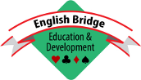

EBED

Youth Bridge Handbook

Contents
1. Overview 2
2. Promoting Bridge Clubs in School 2
2.1 Prospecting 2
2.2 Persuading 3
2.3 Resourcing 3
General Remarks 3
Club Leaders and Helpers 4
Payments to Your Resources 4
DBS Checks 4
3. Attracting Youngsters to an Existing BC 4
4. Finding Potential Bridge Teachers and Helpers 5
4.1 Oxfordshire's Approach 5
4.2 Surrey's Approach 5
5. Teaching Approach and Materials 6
5.1 Designing and Dealing Hands 6
5.2 Computer Apps 6
6. What EBED can Provide 7
7. Helping Schools to Develop 7
8. Sample Material 8
8.1 Prospecting Letters to Schools 8
Stamford Example 8
Surrey Example 8
8.2 Handout for Initial Meeting with School 9
8.3 Poster for MiniBridge Train-the-Trainer Course 10
9. Concluding Remarks 10

Overview
This Handbook, produced by the Youth Advisory Group (YAG) of EBED, aims to help those promoting bridge amongst youngsters. Members of YAG and contributors to this Handbook are:
Bernard Eddleston | EBED Trustee
Richard Banbury | EBED Youth & Business Manager
Joan Bennett | Youth Officer for Oxfordshire (Oxon), but this Handbook also calls on Joan’s experience carrying out the same role previously within Bucks & Berks
Liz Dale | Project Leader, Stamford Youth Bridge Academy, Stamford Bridge Club, Lincs
Tim Warren | Youth Officer for Surrey

We live in various counties around England, with different features and challenges. As a result, each author has his or her own individual approach, but for simplicity and consistency of style we've used "we" and "our" throughout this document. We strongly believe there's not just one 'correct' way to approach things; these are just ideas to help your own thinking, and very much not a specification to be followed slavishly.

Stamford’s approach in these areas has been fully documented as a separate project, and is available at the Stamford Youth Bridge Academy website, www.syba.org.uk. For the most part, therefore, this document tends to focus on the experiences of Oxon and Surrey.

The starting point is: What are you trying to achieve? We think your most likely aims are going to be:
Promoting bridge clubs in schools
Attracting youngsters to existing bridge clubs

These are discussed in Sections 2 & 3. If you have a different aim, please let us know; we may be able to advise, or maybe we can add a section to a later edition.

Section 4 deals with how to find potential teachers and helpers, and Section 5 with where to find teaching materials. Following that, we've set out what EBED can provide in terms of equipment, etc., to help you.

From the point of view of bridge in schools, we focus on getting things started. But in the longer run you might wish to think about helping schools to develop and extend their bridge capability, so we give some brief ideas on this topic in Section 7.

Section 8 then gives some ideas to help you create your own marketing materials, with examples of:
- prospecting letters to schools;
- a handout to talk schools through when you’ve got a meeting with them; and
- a poster to advertise MiniBridge train-the-trainer courses.

We welcome all suggestions and other feedback, and have included contact details for EBED at the end. Good luck!

Promoting Bridge Clubs in School
There are several strands to this:
Prospecting – seeking out schools who might be interested
Persuading – convincing them, once you’ve had a 'bite'
Resourcing – finding leaders and helpers for the school clubs

You'll need to think about these in parallel: if you get a school interested, you won't want them to have to wait ages while you try to find people.

Prospecting
You can find lists of all state schools on your local county council websites, or more generally via Wikipedia or search engines.

Will you focus on a particular group (e.g. primary/secondary, state/private)?
- In Oxon, the focus has mainly been on the primary sector. State secondary schools rarely seem to have time available for lunchtime clubs, and after-school clubs are only patchily attended: in a relatively rural county, pupils are drawn from a wide catchment area and many have to catch end-of-day buses to get home. However, we've also been successful with some grammar schools in nearby Bucks & Berks.
- In Stamford, our focus from the outset has been both primary and secondary: see www.syba.org.uk.
- In Surrey, we set our focus initially on secondary schools, using the logic that a club for 11-, 12- and 13-year olds will have a much longer time horizon before the pupils move on. However, in practice it's been much more school-driven than that so far, i.e. we've worked with whichever school expressed an interest.

How will you get the schools interested? You could try the scattergun approach: sending a letter to all schools, and seeing who responds. This approach might be useful in some circumstances, but in our view it's not a very effective way of getting a school's attention - they get a lot of unsolicited mail, and almost always letters such as this seem to go straight in the bin.

In our opinion, a better way is to use your network of local bridge players to generate interest from schools through personal contact. Many will have children or grandchildren at a local school, or be ex-teachers/governors, and have the opportunity and motivation to find a 'way in'. It can also give you a flying start with the teaching resources you'll need.

However you decide to do it, we've included examples of prospecting letters in §8: Sample Material.

As an aside, we suggest that bridge isn’t just for the academically gifted, but can also be ideally suited to benefit those from disadvantaged backgrounds or with special needs.

Persuading
If you can get yourself in front of a Head or senior teacher, you're probably pushing on a door they want you to open. Your job now is to:
- convince the school that you can help deliver an effective club; and
- provide them with persuasive material they can pass on to parents.

We've included a handout in the Sample Material section, with some simple key messages. It's designed for you to talk it through face-to-face, but is set out over six slides that will be legible on a single printed page, to be left with them. This includes some impressive research from the US about the benefits to children of learning bridge (we strongly recommend reading the source material, via the link included in the text).

One valuable approach is to offer the school a ‘taster session’, where one or more groups of pupils are taken through from the very start (“what's a suit?”, “what’s a trick?”) to playing some hands. A two-hour session for each group seems ideal to us, but you may not have that luxury and you'll need to tailor it to suit the time allowed.

It's important to brief schools on what they need to bring to the table. In particular, we suggest you insist that each school nominates a teacher to take responsibility for club, even if they aren't bridge players themselves and don't play any part in the teaching itself. You risk the school dropping out altogether, but in our experience it's an essential factor for longer-term continuity at the school.

Resourcing

General Remarks
If you are a bridge club, we strongly recommend that you have a Champion within your club to lead any schools initiative in your area. Part of the Champion’s job is to instil enthusiasm for the project with other members, and co-ordinate activities if you have several schools involved.

Don't underestimate the amount of time and effort it takes to run a bridge club in a school. As well as hugely rewarding, teaching a bunch of enthusiastic youngsters who are having a great time can be exhausting. Even if you have the desire, it's very unlikely that you'll have the time available to handle more than one or two. Whilst you may be needed to help get a club embedded in a school in its early days, we'd say your task is to get back to looking for the next opportunity as soon as possible!

Many people would love to help out a bit at a school, but don't want to be tied down to turning up every week throughout the academic year; and anyway they are likely to have holidays, illnesses, etc.

For all these reasons, we suggest you try to assemble a pool of volunteers, from which the club leader can marshal the resources each week. We set out some ideas for how to do this in §4.

Club Leaders and Helpers
For the long-term success of the club, we think it’s essential to find a teacher at the school who will take responsibility for the club, as they're likely to have the classroom control techniques, and links within the school to get things done. If this isn't possible – and if you're not prepared just to walk away – you'll need to find a good leader that you can trust to run the club without calling too much on your help. Previous teaching experience, bridge or otherwise, can be invaluable here; and even if a local bridge teacher can't help out at a school, maybe they know someone who might fit the bill.

Once a school club is established, it might be possible for two people, perhaps just one, to run it on their own. But in the early days, when every pupil is a beginner, we suggest you try to have one adult per table. So, for a club of say 18 pupils, ideally you'd like at least five adults, some of whom may have to make up the spare seats at a table. The helpers don't need to be fully-trained bridge teachers: almost anyone who can play bridge can help youngsters pick up the basics. Much more important than a person's ability to play bridge is their ability to interact and empathise with the youngsters.

Particularly if they're working with a recently-established club in a primary school, say, your resources need to see their efforts as part of long-term campaign. In the early days, when the children are still struggling with holding the cards and remembering what the suits are, your helpers may well feel they are more like child minders than (Mini-)bridge teachers. 'Stick with it, they’ll get there!' can be a valuable message.

Payments to Your Resources
In general, most of your resources will be volunteers, but either way this can be a sensitive topic. If you're working with a private school, they may well charge parents for all extra-curricular clubs. Will any of this be passed on to your club/county association and/or your teachers? If some people at a club take on duties such as preparing hands in advance, will you pay them more? It’s for you to decide, but beware of creating precedents when you go into other schools that don’t charge for such clubs. Some people may actively wish not to be paid, and you will need to respect this.

DBS Checks
All leaders and helpers will need to be DBS checked; that is, be certified by the Disclosure and Barring Service as being able to work with children. If you might be needed to help out occasionally, you'll need to get your own certificate too. Schools will operate their own DBS process, but EBED also provide a service, usually free. Rather than doing a separate one for each school, it can be more efficient to get this carried out (and kept up to date) via EBED. However, check first with the school, as some will accept only their own.

EBED has a comprehensive set of safeguarding policies and procedures, which you can find at www.ebedcio.org.uk/safeguarding. When you approach a school, this is always a potential area of concern, and you'll need to be able to assure them that your approach will meet their needs. We therefore recommend that your club adopts the EBED policy, or we can provide links to safeguarding policies at some of the big clubs.

Attracting Youngsters to an Existing BC
Within Surrey, some clubs have recently put toes in the water but we feel we still have much to learn about what works and what doesn’t.

It’s important to think about the timing from your audience’s perspective. Regular club times are not child friendly. We have, for instance, run MiniBridge taster sessions during a half-term break, followed by a full MiniBridge course on successive days during the next full school holiday. If you find sufficient children who are keen, you might try weekend sessions during term, too.

If you are thinking of running a weekend session, both Oxon and Surrey have found that Sunday afternoons – with tea – work well, as children often have other activities already booked for the mornings.

Publicity is key. Members of your own club, particularly those who are grandparents, will probably be your best source of attendees. They will need time firstly to persuade, and then to reserve a diary slot, and also time to pass the word on to others. Interestingly, we've found spin-off benefits, in that they’ve generated students for adult courses, too.

Following the courses, the clubs have made normal sessions free to youngsters to encourage them to come along. Be aware, though, that they may well prefer to play online. Bridge will gain, even if not always your physical club.

Stamford also have considerable experience here; see www.syba.org.uk.

Finding Potential Bridge Teachers and Helpers
In our experience, it’s clear that many bridge players adore the game, and would dearly love to help youngsters learn, not least because of the apparent steady increase in the average age of players at many clubs. How do you tap into this?

In the various counties, our approaches have differed, so we've described them separately here. But there are some common points we all agree on:
- Have an enthusiastic champion in your club or county
- Make sure your club county committee are fully supportive of your initiative and advertise it widely
- Train up a population of potential helpers
- Communicate regularly with all your helpers, by email or newsletter, to keep them informed of progress and committed to your cause

Oxfordshire's Approach
Starting in 2009, we had a big push in clubs that were keen, and were delighted with the number of people who came forward. At the beginning, it worked well to run ‘train the trainer’ courses, later augmenting these with ‘How to start them bidding’, but the need for these has become less over time, as the retiring volunteers tend to bring on their own replacements. Many bridge players are members of two or three once-a-week clubs, which helps both with word-of-mouth publicity, and with the longer-term continuity.

Sending out general emails tends not to be successful, but chatting to individuals over tea breaks has been much better. For some reason, this can vary a lot by club.

Surrey's Approach
In Surrey, our approach has been to:
- Put on free-to-attend training courses for potential MiniBridge teachers
- Visit local bridge clubs and encourage players to get involved: like Oxon, this has had more success than general exhortation via newsletters, etc.

To start with, we took a chance and put on a train-the-trainer course for potential teachers, hosted by a club in the most heavily-populated area in our region, and using EBED's Red Book as the basis. Even though the club gave its premises free, the cost was not inconsiderable, but we felt it was worth a tentative investment. (In the end, we managed to get sponsorship for the course; it’s not appropriate to go into this in detail here, but we would be happy to discuss it if you'd like to contact us.) Part of the cost was for a light lunch – and it turned out to be one of the most valuable parts of the course, as it gave everyone the chance to interact less formally, as well as us the chance to encourage people to volunteer for local schools.

We have since arranged further courses in a different corner of the county, and have been impressed with the level of interest and enthusiasm.

If you do the same, make sure you record the postcode of all those who attend your course, as well as their contact details. We plotted the postcodes on a map; it was a lot of work, but when a potential school comes up it’s very easy to find which teachers are local.

It’s important to market the course extensively. To do this, we suggest you:
- Create a poster to advertise it (there's an example in Useful Material, §C)
- Display it prominently on your county’s website, and ask EBED to do the same
- Enlist the help of the host club and other clubs within range, and get them to publicise it
- Email the poster to nearby counties’ youth reps – they may know of potential teachers just over the border, or they might want to come along themselves
- Publicise it in your county’s newsletter

You'll need to start your marketing well in advance of the course. It takes time for the message to percolate out via bridge players’ informal networks, and we suggest you allow at least three months. We tried to run our second course with two months’ notice, and ended up having to cancel it for lack of attendees.

We’re sure you can add other ideas, too; for instance, some members of your club may have no idea what MiniBridge is, so why not host a fun MiniBridge session to kick-start your volunteer recruitment campaign? If you find something else that works well for you, please let us know.

In your message to potential teachers, make it clear that you're not going to insist they help out at schools every week. Many of them will wish to be free to have holidays away, and will not want to feel tied to the school.

Teaching Approach and Materials
In Oxon and Surrey, we normally start youngsters in schools on MiniBridge. As the basis for our lessons, we use Book 1: Beginning Bridge (informally called the Red Book) from EBED’s Bridge for All national learning programme, www.ebu.co.uk/education/bridge-for-all/programme. It has a large body of associated material, including prepared hands and teaching notes. In Stamford, we've developed our own training material, available via www.syba.org.uk. This is also being used by other areas, such as Hertfordshire.

The Red Book provides a structured approach, starting with MiniBridge and then moving on through bidding and basic card play techniques. Many newcomers to the game will themselves be familiar with its layout. Individual chapters include discussion and subsequent practice hands, so the book could also be used to furnish homework for a junior class.

In Oxon, the approach translates into the following outline schedule, assuming a school year start:
Start the year 5s or 6s (age 9-11) on a MiniBridge taster session.
For those that continue, teach No Trump play for 4-6 weeks, then introduce trumps: this means that by Christmas they can choose game/part score, and trumps/NT.
Consolidate for a term or so before introducing them to bidding.
Scoring is not used until there is a reason to do so (e.g. in time for the EBED Simultaneous Pairs – see next section) as we find children would rather just play. Timing will vary depending on the children themselves from year to year, and also the school. For instance, one of our schools has been running for eight years, and we find that many younger siblings can play when they arrive.

Designing and Dealing Hands
We don’t recommend teaching children to deal hands manually: firstly, shuffling and dealing is not an easy task for small fingers; and secondly, you have more important things to focus on in the time available.

Rather, you or your club leader will need to set up the hands in advance. You could deal them yourself manually, but you risk distributions, etc., that beginners will not be equipped to handle. Making up hands that are appropriate for different stages of learning is a significant task, so unless you already have a bank of material that you're confident meets the needs, we suggest you take hands from the Red Book, or the SYBA material.

EBED organises a free national event, known as the Student Simultaneous Pairs, open to bridge students of all ages, and involving many juniors and schools. We source a set of hands suitable for both Minibridge and bridge which can be played at any time over a month-long period, with the scores compared with all those taking part across the country. The hands come with a commentary which volunteers can then use as a teaching aid. Teachers and volunteers can take part if there is an odd number – and of course the event could be combined with a neighbouring school or teaching group as well.

Some websites allow you to download hands, perhaps at a fee. No Fear Bridge, www.nofearbridge.co.uk, is a good example; at the time of writing, we understand this is free for youth bridge teachers.

In Oxon, we have a central dealing machine with Jannesten boards for use by the school teams.

Computer Apps
There’s an increasing number of good apps available for phones, tablet PCs, etc. This is not the place to recommend individual products – such recommendations would probably go out of date very quickly – but contact us if you need advice. We do suggest that at least one person in each team learn how to exploit these apps, as they will encourage kids to play outside school time.

What EBED can Provide
Many counties and clubs are able to provide support, either financial or practical, for junior bridge activities. In addition to this, EBED can supply on a free-of-charge or low-cost basis a wide variety of equipment, teaching materials and books which volunteers may need. This includes cards, boards, tablecloths, card-holders for those with little fingers, and sometimes, as the junior group develops, tables or bidding boxes. Financial support can be provided for occasional needs such as taster sessions or perhaps prizes for end of term. Teaching resources, duplimate hand files, help with producing flyers and participation/award certificates are also available as needed.

Twice a year, EBED arranges for school bridge groups to visit the Houses of Parliament for a tour of the buildings and to play bridge or MiniBridge against the Peers. This can often be co-ordinated with the involvement of local MPs, and it provides an opportunity for additional publicity within the school or local media.

As well as administering the Junior Award Scheme (www.ebedcio.org.uk/junior-award-scheme), EBED runs national junior events such as the Student Simultaneous Pairs mentioned above, the Junior Teach-In, the Schools Cup, and the Portland Cup for universities. We also work closely with third parties and county associations to arrange grants towards the costs of bigger junior projects.

We are also here to provide advice if you find yourself facing an unexpected challenge!

Helping Schools to Develop
In the short term, the first question you might well encounter is: How do we move the youngsters from MiniBridge into bidding? This can be a particular issue where they say, in effect, “we just want to play cards!”. The answer will depend very much on the individual pupils, but it’s important for your club leader and volunteers to have a clear plan for doing so. Oxon have run a course specifically on this topic, and we can also help with advice.

Once you’ve got past that stage, we strongly recommend you take pupils through the Junior Awards Scheme (see link above). The scheme breaks down developing from raw rookie to serious contender into a set of steps and milestones which can be easily understood and evaluated in the classroom. These skills, covering bidding, play and defence, are grouped into six progressive levels of attainment: Minibridge, Bronze, Silver, Gold, Platinum and Diamond. Each level requires the pupil to demonstrate about twenty increasingly difficult elements of technique.

Both pupils and schools relish having certificates awarded for achievement, to be presented at school assemblies, etc. In the early stages, it’s often appropriate to award certificates to everyone in a group even if some may still need improvement in a few areas – the idea is to encourage, and provide structure and clear goals.

Bridge is recognised as a Skill for the Duke of Edinburgh Award Scheme, and the Junior Award Scheme is evidence that they have demonstrated the necessary achievement. It may be worth recruiting older children to help teach younger ones, as that would qualify towards the Service & Volunteering element as well.

In the longer term, you might run an inter-schools competition, with a trophy for the winner(s). Schools love to show parents that they are competing with others. However, some school teachers will fear that their pupils aren't good enough to take part, so consider how you might counter that – almost certainly misplaced – fear. Think about it from the school's perspective and help those who do well to gain publicity, both nationally and locally. In Surrey, we've run the Surrey Schools' Cup for many years, and we can help with advice. We've sought to counter that “we’re not good enough” fear by introducing an event for those new to full bridge.

Encourage them to join in the national events such as the EBED Schools Cup, Junior Teach-In, etc. There are often regional events, too; for instance, in 2016 and 2017 there were junior weekends in both Sussex and Gloucestershire; Oxon ran the latter, and can help with equivalents elsewhere.

Sample Material
The following pages give some ideas to help you create your own letters, etc. We've included:

Prospecting Letters to Schools
Handout for Initial Meeting with School
Poster for MiniBridge Train-the-Trainer Course

Prospecting Letters to Schools

Stamford Example
There is a sample letter on the SYBA website, www.syba.org.uk

Surrey Example
Would you like to set up a Bridge Club at {school name}?

Bridge helps develop a very broad range of skills:
Academic Counting, mental arithmetic, calculating probabilities, memory
Problem-solving Analysis, reasoning, planning, testing/observation/re-planning
Social Teamwork, communication and collaboration

But it’s much more than that. Bridge fosters respect for others, and putting yourself in others’ shoes; it helps the young become mature, well-rounded people.

Bridge is welcomed for the Duke of Edinburgh’s Award, lots of schools take part in matches against other schools, and there's a national Junior Award Scheme that youngsters can progress through.

And, of course, playing bridge is fun! It’s a great game for them to take into adult life.

How can we help you?

We’ll supply trained volunteers to help you set up and run a club, and we can provide you with packs of cards, set hands, scoresheets, access to websites, etc. We’ll need a school teacher to be responsible for the club, but they don’t need to be bridge-players – though if you wish there's free bridge training for your teachers, too.

Why not put a toe in the water?

How about us running a ‘MiniBridge Taster session’ at your school, at the end of this term? MiniBridge is a simplified form of the game designed for beginners. We’ll take pupils through from the very start (“what's a suit?”) to playing some hands. If several of them enjoy it – and they always do – we can then start up a bridge club in Autumn term.

I will call in a few days’ time, but if you would like to reach me in the meantime, I’d love to hear from you – the best way is just to reply to this email.

Yours sincerely,

Handout for Initial Meeting with School
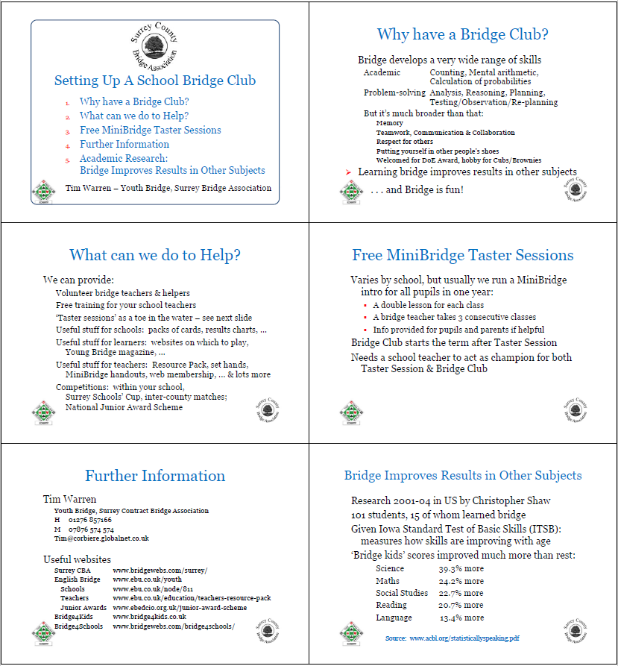

You can download the PowerPoint version of this file from http://www.ebedcio.org.uk/youth.

Poster for MiniBridge Train-the-Trainer Course
Poster used by Surrey YO, 2017
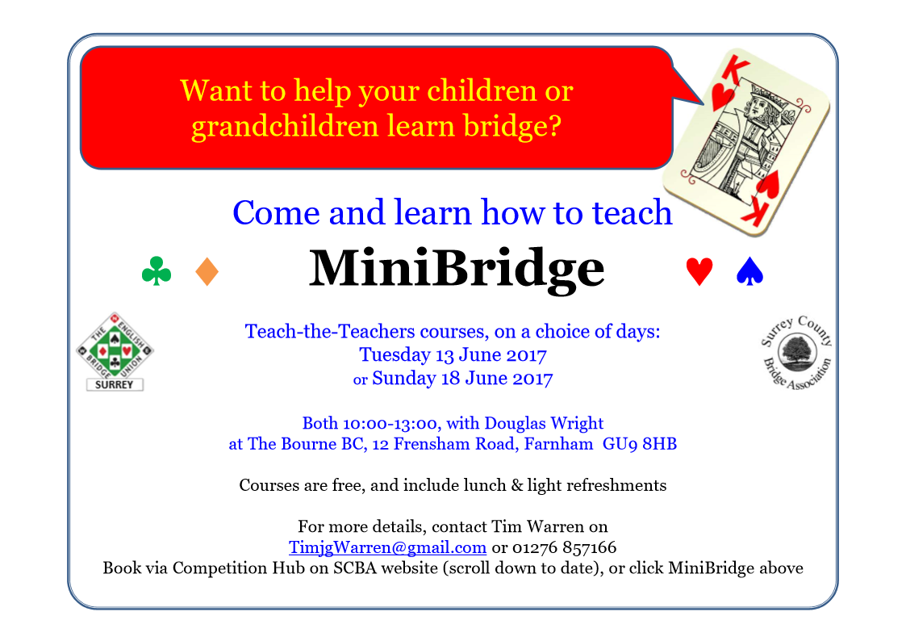
You can download the PowerPoint version of this file from http://www.ebedcio.org.uk/youth.

Concluding Remarks
Good luck in your efforts to promote bridge. If you'd like to discuss anything in this document, suggest additions or changes, or even just have a chat, we're very happy for you to contact us.

Richard Banbury Richard@EBEDcio.org.uk 01296 317218

You can find lots of information about EBED's youth programme at http://www.ebedcio.org.uk/youth, and in particular lists of County Youth Officers at http://www.ebu.co.uk/youth/county-officers.

