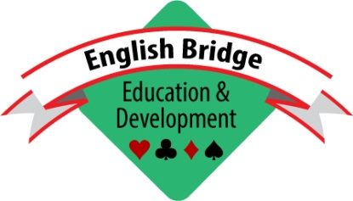

EXPRESSION OF INTEREST IN BECOMING A TRUSTEE OF
ENGLISH BRIDGE EDUCATION & DEVELOPMENT (EBED)

This form is not an application, simply an expression of interest in possibly becoming an EBED Trustee and an agreement to being approached if a suitable Trustee vacancy becomes available. Please email the completed form to donna@ebedcio.org.uk.

1 | Full Name

2 | Please indicate any aspects of professional experience or public service which help to qualify you for Trusteeship. Include here professional qualifications, experience and anything else that you consider relevant to being a trustee

3 | Employment Status

4 | Please detail any past and present activity in bridge administration (at club, county or national level) or any involvement with Bridge teaching

Signed -------------------------------------------------------------------------------

Date --------------------------------------

